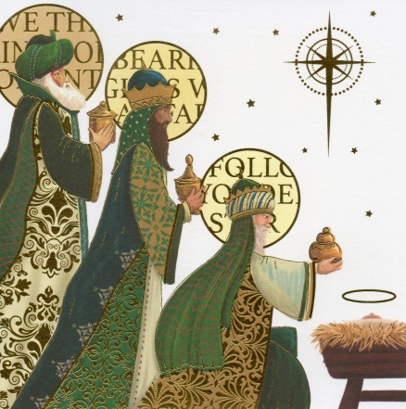

Holy Trinity Langdale

Carol Service

Sunday 17th December

3.00pm

Christmas Day Family Service

with Communion

11.00am

No Christmas Eve Service this Year